**DATA ANALYTICS PROJECT**

***The Tableau HR Scorecard: Measuring Success in Talent Management***

Team Members:

1. Pratyusha Mohanty – 20BEC0201
2. Vineela Reddy M – 20BCT0257
3. Vaishnavi Kolichala – 20BEC0469
4. Reshma Ramakrishnan – 20BEC0431

**The Tableau HR Scorecard: Measuring Success In Talent Management**

The HR Scorecard consists of four main perspectives:

1. Financial Perspective: This perspective focuses on the financial impact of HR initiatives, such as the cost of recruitment, training and development, compensation and benefits, and turnover.
2. Customer Perspective: This perspective measures the satisfaction of internal and external customers of HR services, including employees, managers, and job candidates. It includes KPIs such as employee engagement, manager satisfaction with HR support, and candidate experience.
3. Internal Process Perspective: This perspective assesses the effectiveness and efficiency of HR processes, such as recruiting, onboarding, performance management, and employee development. It includes KPIs such as time to fill vacancies, time to productivity for new hires, and training hours per employee.
4. Learning and Growth Perspective: This perspective evaluates the organization's investment in employee development and its ability to innovate and adapt to changing business needs. It includes KPIs such as employee skills and competencies, employee retention, and the percentage of employees who receive regular training and development.

**Technical Architecture:**

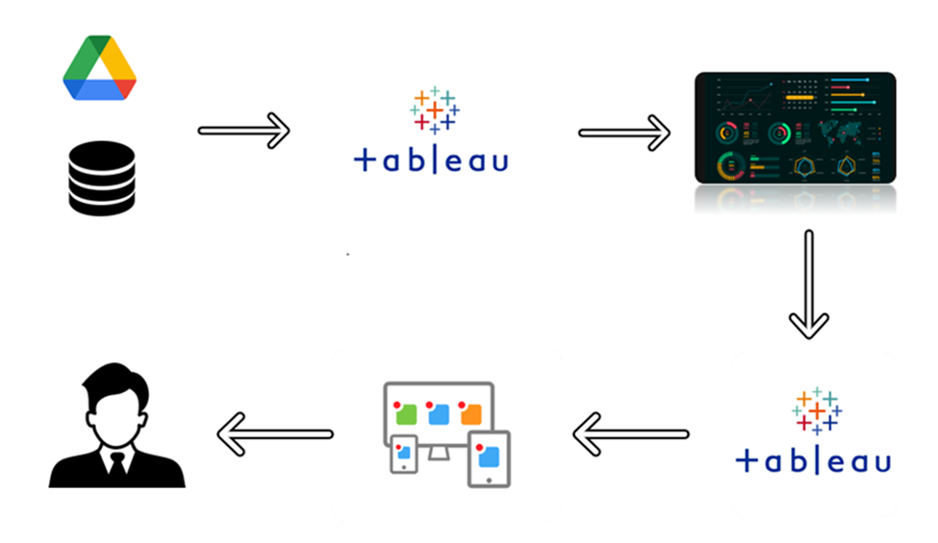

**Project Flow:**

To accomplish this, we have to complete all the activities listed below:

Define Problem / Problem Understanding

* Specify the business problem
* Business requirements
* Literature Survey
* Social or Business Impact.

Data Collection & Extraction from Database

* Collect the dataset,
* Storing Data in DB
* Perform SQL Operations

**Problem Understanding**

Defining the problem and gaining a thorough understanding of it is an essential step in any problem-solving process. It involves clearly identifying and comprehending the specific challenge or issue at hand.

**Business Problem:**

The business problem for producing Tableau visualizations for the topic "The Tableau HR Scorecard: Measuring Success in Talent Management" could be the necessity for an organization to efficiently measure and track important metrics linked to talent management. Recruitment, retention, performance management, training and development, and succession planning are all parts of talent management.

Understanding and evaluating talent management strategies and initiatives can be difficult for organizations. They require a comprehensive and simple method for assessing the effectiveness of these efforts. This is where the Tableau HR Scorecard can help. It attempts to give visual representations of significant HR metrics and key performance indicators (KPIs) to help HR professionals and stakeholders measure and monitor talent management performance.

Some specific business problems that could be addressed through visualizations in Tableau for the HR Scorecard might include:

1. Lack of visibility: Organizations may find it difficult to acquire a clear and comprehensive image of their talent management activities. They may have data distributed across multiple platforms and struggle to adequately consolidate and analyze it. Tableau visualizations can assist in bringing together disparate HR data sources into a single dashboard, delivering a consolidated picture of critical indicators.
2. Data complexity: HR metrics for talent management can be complicated and nuanced. Time-to-fill, cost-per-hire, and quality of hire are examples of recruitment metrics. These complex measurements can be simplified and presented in a visually appealing and consumable style through visualizations, allowing stakeholders to easily comprehend and interpret the information.
3. Performance tracking: It is critical to track the success and impact of people management programmers. Visualizations can assist organizations in identifying trends, patterns, and correlations in HR data, allowing them to monitor the performance of their policies. Employee engagement, retention rates, performance ratings, and learning and development indicators can all be tracked over time.
4. Decision-making support: HR professionals and organizational executives are frequently required to make data-driven talent management decisions. Real-time insights and data can be provided via visualizations, allowing decision-makers to discover areas for improvement, make educated decisions, and allocate resources effectively.

Overall, the business problem for developing Tableau visualizations for the HR Scorecard is to improve understanding, monitoring, and evaluating talent management initiatives by delivering clear, simple, and actionable visual representations of HR metrics and KPIs.

**Business Requirements:**

The business requirements for "The Tableau HR Scorecard: Measuring Success in Talent Management" would typically include the following:

1. HR Metrics and KPIs: Determine the exact HR metrics and key performance indicators (KPIs) that are useful for monitoring talent management success. Employee turnover rate, time to replace vacant jobs, training and development efficacy, employee happiness or engagement levels, performance ratings, diversity and inclusion measures, and succession planning are examples of such indicators.
2. Data Integration: Data integration from various HR systems and sources, such as HRIS, performance management systems, learning management systems, and recruitment platforms. Data from these sources should be able to be pulled into the HR scorecard visualisations and consolidated into a single view for analysis.
3. Data Accuracy and Quality: Make certain that the data utilised for the HR scorecard visualisations is accurate, dependable, and of high quality. To guarantee the integrity of the data utilised for analysis, data governance protocols, data validation checks, and data cleansing procedures must be established.
4. Performance Tracking: Allow for the monitoring of talent management performance throughout time. The visualisations should give stakeholders with a historical picture of HR measurements and KPIs, allowing them to examine trends, identify areas for improvement, and assess the effectiveness of talent management activities.
5. Comparative Analysis: Allow for the comparison of talent management performance across departments, teams, or locations within the organisation. This could entail developing visualisations that allow stakeholders to benchmark performance and identify areas of excellence or need for improvement.
6. Visualization Flexibility: The visualisations should be adaptable and customizable to satisfy the demands and preferences of various stakeholders. This includes the ability to select multiple forms of visualisations (for example, bar charts, line charts, heat maps, and so on), customise colours and styles, and select suitable filters or dimensions for analysis.
7. User-Friendly Interface: HR scorecard visualisations should be intuitive and user-friendly, catering to both HR professionals and other stakeholders who may lack data analytic expertise. The interface should make it simple to navigate, explore, and interpret the visualisations.
8. Actionable Insights: Based on the analysed HR data, the visualisations should deliver actionable insights and recommendations. This could include identifying possible talent gaps, flagging areas of concern, or offering particular interventions or tactics to improve personnel management outcomes.
9. Security and Privacy: Check that the HR scorecard visualisations follow data security and privacy requirements. It is vital to safeguard sensitive HR data and ensure that access to visualisations is adequately regulated and validated.
10. Scalability and Performance: The visualisations should be able to handle enormous amounts of HR data while remaining efficient even while performing sophisticated computations and aggregations. This is critical to ensuring that the visualisations remain responsive and deliver a consistent user experience as the organization's data grows.

By meeting these business needs, Tableau's HR scorecard visualisations may effectively assess and track talent management success, provide actionable insights, and support data-driven decision-making in HR and organisational strategy.

**Literature Survey:**

Talent management is a critical aspect of human resource management, focusing on attracting, developing, and retaining high-performing employees. HR dashboards utilizing Tableau visualization can be valuable tools for measuring success in talent management initiatives. This literature survey aims to explore the existing literature on HR dashboards using Tableau visualization specifically designed to measure success in talent management, providing insights into the applications, benefits, and best practices in this domain.

* "Using HR Analytics and Dashboards to Drive Talent Management Success" by D. Welch and A. Milkovich (2019):

This article highlights the use of HR analytics and dashboards, including Tableau, to drive talent management success. It discusses the importance of aligning talent management metrics with organizational goals and presents case studies showcasing how Tableau visualizations can provide actionable insights into talent acquisition, development, and retention. The article emphasizes the role of HR dashboards in measuring the effectiveness of talent management strategies.

* "Building a Talent Management Dashboard: A Case Study" by S. Kausar and S. Zahid (2020):

This case study presents the development and implementation of a talent management dashboard using Tableau. The authors describe the process of identifying relevant talent management metrics, designing visually appealing dashboards, and integrating data from multiple sources. The study demonstrates how Tableau's interactive features enable HR professionals to monitor and measure the success of talent management initiatives effectively.

* "Measuring Success in Talent Management through HR Dashboards: A Conceptual Model" by A. Singh and N. Kapoor (2018):

This conceptual paper proposes a model for measuring success in talent management through HR dashboards. The authors discuss the key metrics and indicators that should be incorporated into a talent management dashboard, including employee performance, turnover rates, employee engagement, and succession planning. The study provides insights into how Tableau's visualization capabilities can be leveraged to track and evaluate talent management success.

* "Visualizing HR Analytics: A Case Study on Talent Management" by P. Sathyanarayana and P. Prakash (2020):

This case study focuses on visualizing HR analytics specifically for talent management using Tableau. The authors showcase how Tableau can be used to create interactive dashboards that monitor key talent management metrics, such as recruitment effectiveness, performance appraisal outcomes, and training and development investments. The study highlights the advantages of using Tableau for talent management visualization and the impact it can have on decision-making.

* "Using Tableau for HR Analytics: Measuring Success in Talent Management" by A. Sharma and S. Gupta (2019):

This research paper explores the utilization of Tableau for HR analytics in talent management. It discusses the significance of data visualization in understanding talent management performance and presents a framework for designing an HR dashboard using Tableau. The study emphasizes the need for aligning talent management metrics with organizational objectives and provides insights into measuring success through visualizations.

The literature survey demonstrates the value of HR dashboards using Tableau visualization in measuring success in talent management. Tableau's capabilities enable HR professionals to track and evaluate key talent management metrics effectively. By leveraging Tableau's features, organizations can develop interactive and visually appealing dashboards that provide actionable insights into talent acquisition, development, and retention. The studies reviewed emphasize the importance of aligning talent management metrics with organizational goals and highlight the role of HR dashboards in driving talent management success.

**Social or Business Impact:**

The Tableau HR Scorecard: Measuring Success in Talent Management can have significant social and business impacts. Here are some examples:

1. Enhanced Talent Management: The HR Scorecard offers organisations with a holistic perspective of talent management performance, allowing them to evaluate strengths and shortcomings in their talent management initiatives. Organisations may improve recruiting, retention, employee development, and succession planning by measuring important indicators and KPIs. As a result, talent management practises become more successful, and employees and the organisation as a whole benefit.
2. Improved Employee Engagement and Satisfaction: Measuring and tracking HR indicators related to employee engagement and satisfaction can assist organisations in understanding how employees view the workplace and identifying opportunities for development. Organisations can build a more engaging and satisfying workplace by addressing issues raised by the HR Scorecard, resulting in enhanced employee morale, productivity, and loyalty.
3. Informed Decision-Making: The HR Scorecard delivers vital insights and statistics to HR professionals and organisational executives in order for them to make informed decisions about talent management strategies and resource allocation. The visualisations and data analysis let stakeholders understand the impact of various efforts, assess their effectiveness, and make necessary improvements. This results in more informed decisions and more targeted investments in personnel management activities.
4. Strategic Workforce Planning: The HR Scorecard assists organisations in identifying talent gaps, succession planning requirements, and skill development opportunities. Organisations may proactively plan for future talent needs by analyzing HR data and trends, ensuring they have the right people with the necessary skills to accomplish business objectives. This strategic workforce planning adds to the organization's long-term performance and sustainability.
5. Increased Accountability and Transparency: The HR Scorecard encourages transparency and accountability in personnel management practises. Organisations can demonstrate their commitment to fair and equitable HR practises by measuring and visualizing HR indicators. This openness fosters trust among employees, stakeholders, and future applicants, thereby improving the organization's reputation and employer brand.
6. Compliance and Risk Mitigation: The HR Scorecard can assist organisations in monitoring compliance with talent management-related legal and regulatory requirements. Organisations can identify possible areas of risk and take proactive efforts to resolve any discrepancies or non-compliance issues by tracking and reporting on diversity, inclusion, and equal opportunity indicators. This reduces legal concerns while also promoting a diverse and inclusive workplace.
7. Competitive Advantage: Achieving a competitive advantage requires effective talent management. Organisations can recruit and retain top personnel, stimulate innovation, and beat competition by using the HR Scorecard to monitor success and continuously improve talent management practises. As a result, your company's market position improves and your chances of success rise.

Overall, the Tableau HR Scorecard and its impact on assessing talent management success contribute to organisational growth, employee satisfaction, and better business outcomes. It enables organisations to integrate their personnel management strategies with business objectives, optimize worker performance, and maintain a market competitive edge.

**Data Collection & Extraction From Database**

Data collection is the process of gathering and measuring information on variables of interest, in an established systematic fashion that enables one to answer stated research questions, test hypotheses, and evaluate outcomes and generate insights from the data.

**Collect The Dataset:**

We obtained the dataset from kaggle and started working on the implementation of The tableau HR Scorecard which is Measuring Success in Talent Management

Column Description for The Tableau HR Scorecard: Measuring Success in Talent Management:

1. Attrition- It represents the number of people leaving the organization.
2. Department- It represents the employees working in different types of department
3. Education Field- It represents the employees working in the organization from different education fields.
4. Gender- It represents the gender of employees working in the organization.
5. Job Role- It represents the job role of the organization.
6. Marital Status- It represents whether the employees working in the company are married or not.
7. Over time- It represents the employees working overtime or not.
8. Over 18- It represents the employees working in the company who are above 18.
9. Age- It represents the age of the company.
10. Distance from home- It represents the distance of the residence of the employees from the company.
11. Education- It represents the qualification of the employees.
12. Employee count- It represents the number of employees in the company.
13. Job satisfaction- It represents the job satisfaction of the employees.
14. Monthly income- It represents the monthly income of the employees working in the organization.
15. Percent salary hike- It represents the percentage of salary hike of the employees.
16. Performance rating- It represents the performance rating of the employees according to their work.
17. Standard hours- It represents the standard hours of work.
18. Years in current role- It represents the number of years worked at the current profile.

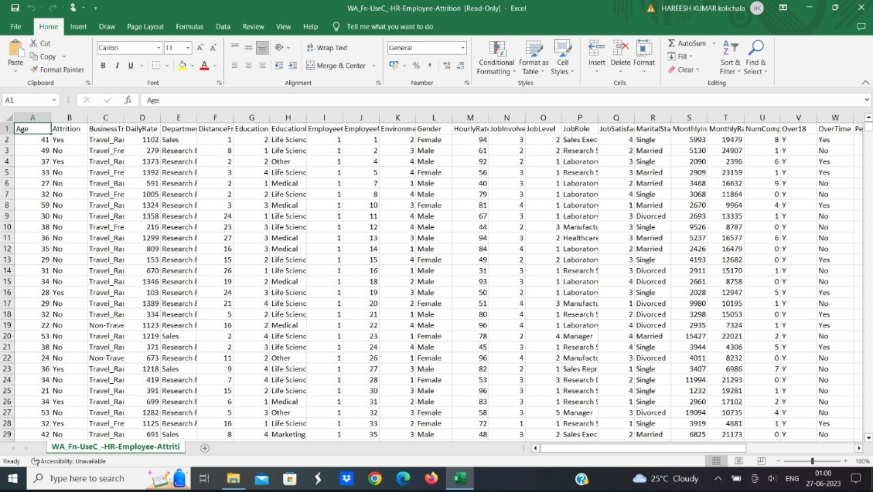

**Storing Data In DB & Perform SQL Operations:**

In order to store the data in the database and to carry out with the visualisations : First, select a suitable database management system (DBMS) such as MySQL, Microsoft SQL Server, PostgreSQL, or Oracle. Next, set up the chosen DBMS by installing and configuring it on your machine or a server, following the vendor's instructions.Design the structure of your HR database by determining tables, relationships, and attributes. Identify relevant data fields like employee information, performance metrics, and attendance records. Create the necessary tables in the database using SQL. Specify the appropriate data types and constraints for each field. Save the Excel data in a format that can be easily imported into the database, such as a CSV file or by using database-specific import tools. Import the Excel data into the corresponding tables in the database using the DBMS's management tools or SQL commands. Validate and clean the imported data, ensuring accuracy and consistency. Address any data quality issues or missing values through data cleaning operations

**Connect DB With Tableau:**

Launch Tableau and establish a connection to the database where you stored the HR data. Tableau supports various connectors for different database systems. Using Tableau's intuitive interface, create visualizations based on the HR data. Select suitable chart types, filters, and dimensions to display desired insights in the HR dashboard. Customize the dashboard by arranging and designing the visualizations according to your preferences. Add interactive elements, filters, and drill-down options to enhance user experience and interactivity. Publish the HR dashboard on Tableau Server or Tableau Online, configuring appropriate permissions and sharing settings, so that relevant stakeholders can access and benefit from it. By following these steps, we can store the Excel data in a database and utilize Tableau's powerful visualization capabilities to create an interactive HR dashboard. The attributes that we are considering for measuring the success in talent management are : KPI, Attrition by Gender, Department wise Attrition, Number of Employees by Age group, Job satisfaction rating, Education field wise attrition and Attrition rate by gender for different Education field

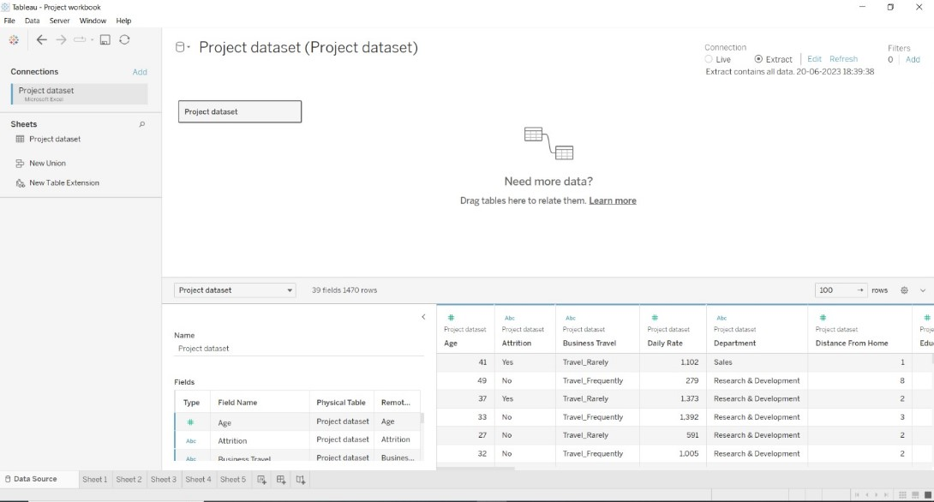

Link: https://drive.google.com/file/d/1YZZEQfCAI6U3u9wXHlCNCAjlNcWNRNE3/view?usp=sharing

**Prepare The Data For Visualization**

Preparing the data for visualization involves cleaning the data to remove irrelevant or missing data, transforming the data into a format that can be easily visualized, exploring the data to identify patterns and trends, filtering the data to focus on specific subsets of data, preparing the data for visualization software, and ensuring the data is accurate and complete. This process helps to make the data easily understandable and ready for creating visualizations to gain insights into the performance and efficiency.

**Data Visualization**

Data visualization is the process of creating graphical representations of data in order to help people understand and explore the information. The goal of data visualization is to make complex data sets more accessible, intuitive, and easier to interpret. By using visual elements such as charts, graphs, and maps, data visualizations can help people quickly identify patterns, trends, and outliers in the data.

* 1. **KPI**

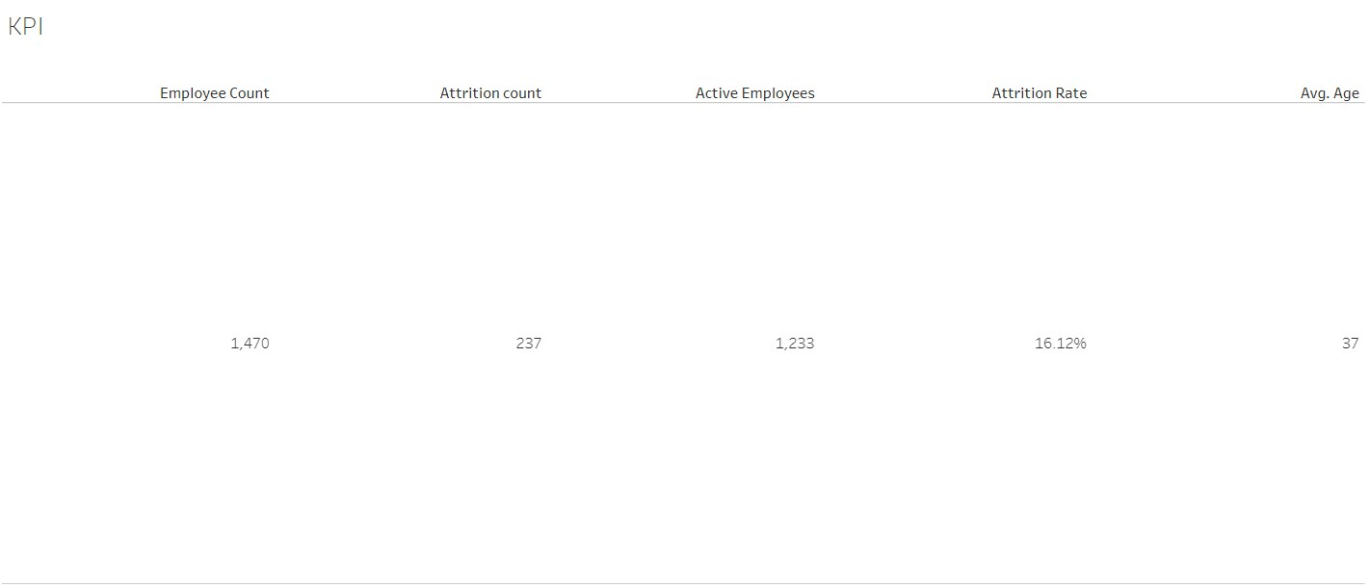

**Link:**

[**https://drive.google.com/file/d/11RxvD7h5e4b9H_aqm6hmBWqnrqcNTZMh/view?usp=sharing**](https://drive.google.com/file/d/11RxvD7h5e4b9H_aqm6hmBWqnrqcNTZMh/view?usp=sharing)

* 1. **Attrition By Gender**

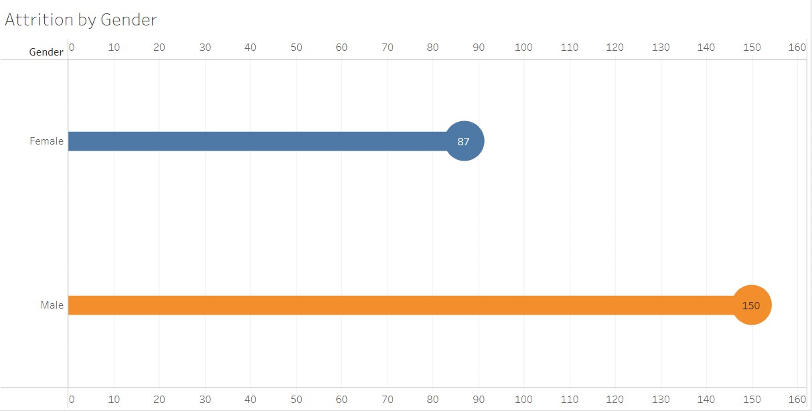

Link: <https://drive.google.com/file/d/1qxnJT6G5ZvhhTrapOSL1Ht3RAa5sm-kt/view?usp=drive_link>

* 1. **Department Wise Attrition**

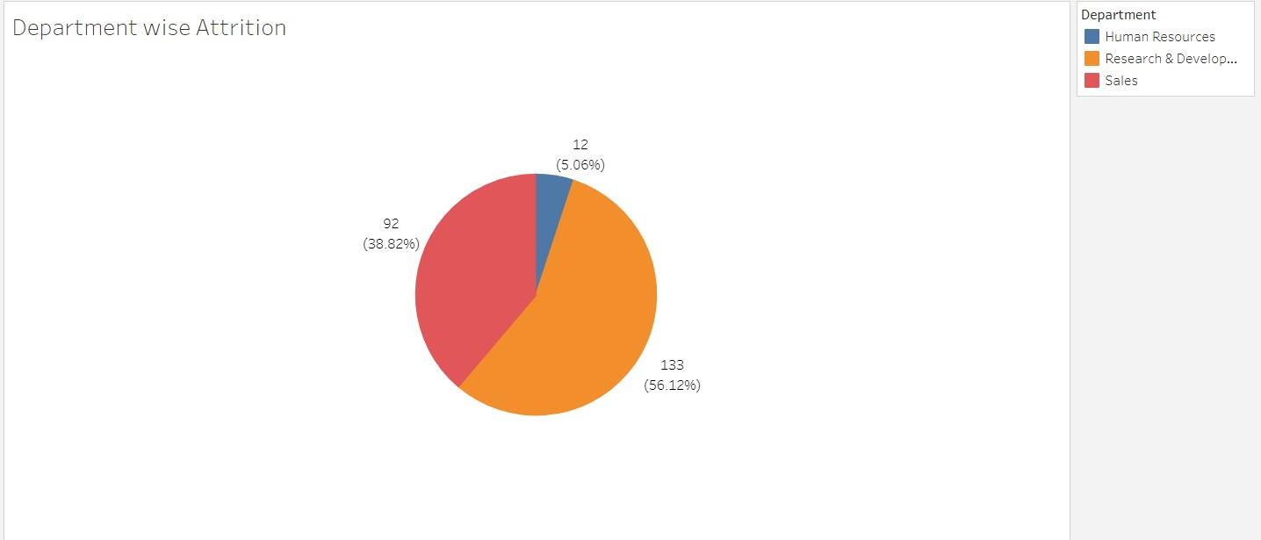

Link: https://drive.google.com/file/d/13DS_CniuIAXXzJiN6oySnPs2eVRb5ft6/view?usp=sharing

* 1. **Number of Employees by Age Group:**

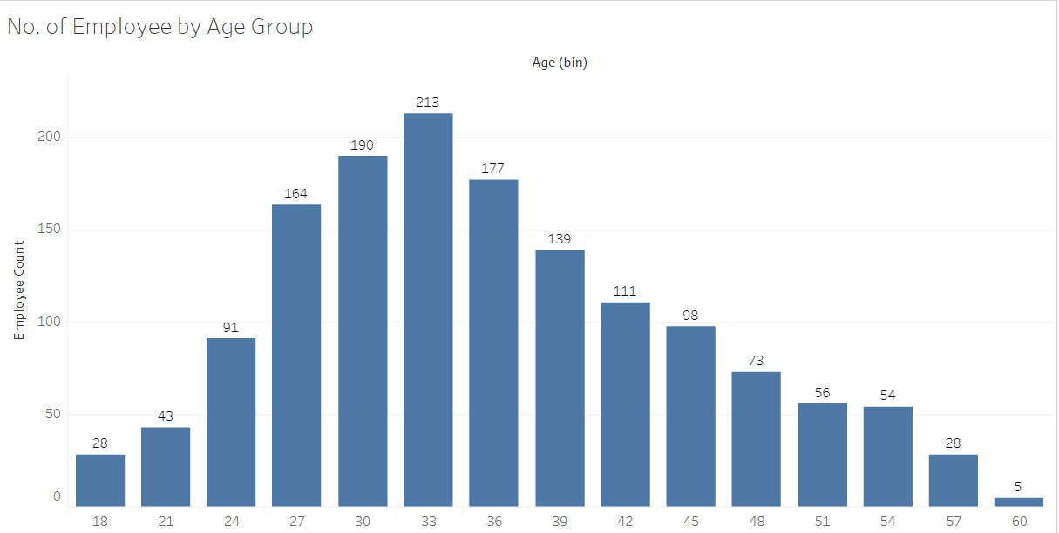

**Link: https://drive.google.com/file/d/1ovgfzu6wOlnfqsUCjuCBguLUFmDrCByr/view?usp=sharing**

* 1. **Job Satisfaction Rating:**

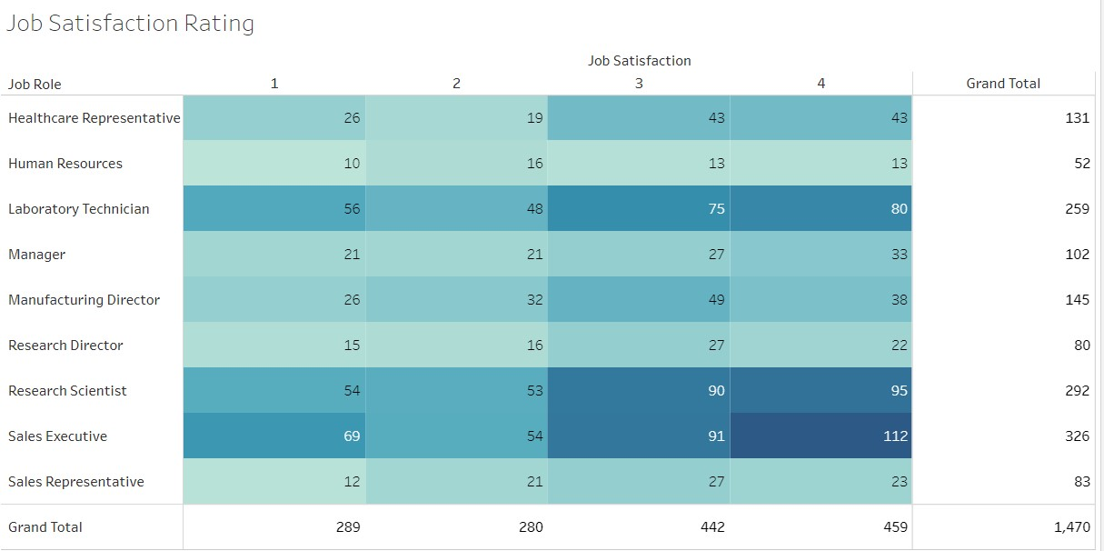

Link: https://drive.google.com/file/d/10BQRaZ_-yxoYhnP1_NlAKF6psuOyfPMk/view?usp=drive_link

* 1. **Education field wise Attrition:**

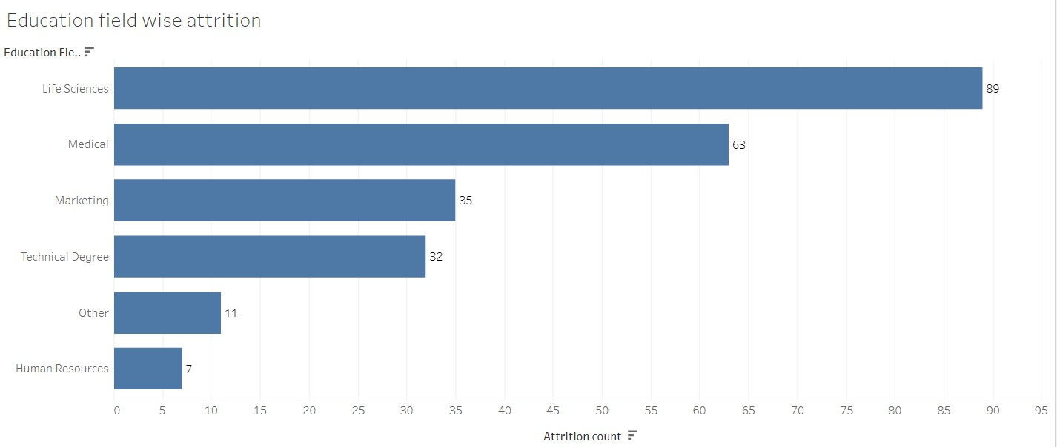

**Link:**https://drive.google.com/file/d/1BLCxBMyI0LvNTTSWVE_Eur08lQGzgrTq/view?usp=drive_link

* 1. **Attrition rate by gender for different education field**

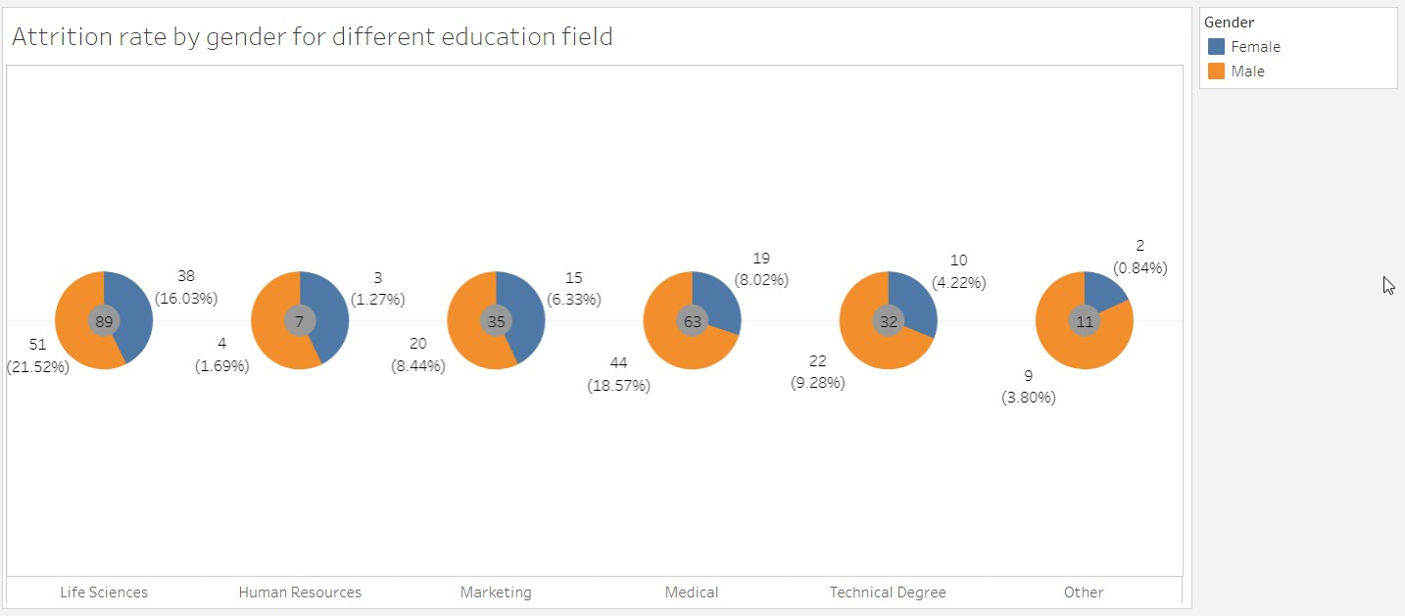

**Link:** [**https://drive.google.com/file/d/17s-yMI1T8U05Rf-soeW_AoQqZnf-_Eoi/view?usp=drive_link**](https://drive.google.com/file/d/17s-yMI1T8U05Rf-soeW_AoQqZnf-_Eoi/view?usp=drive_link)

**Dashboard:**

A dashboard is a graphical user interface (GUI) that displays information and data in an organized, easy-to-read format. Dashboards are often used to provide real-time monitoring and analysis of data, and are typically designed for a specific purpose or use case. Dashboards can be used in a variety of settings, such as business, finance, manufacturing, healthcare, and many other industries. They can be used to track key performance indicators (KPIs), monitor performance metrics, and display data in the form of charts, graphs, and tables.

The responsiveness and design of a dashboard for The Tableau HR Scorecard: Measuring Success in Talent Management is crucial to ensure that the information is easily understandable and actionable. Key considerations for designing a responsive and effective dashboard include user-centered design, clear and concise information, interactivity, data-driven approach, accessibility, customization, and security. The goal is to create a dashboard that is user-friendly, interactive, and data-driven, providing actionable insights to analyze vehicle collisions.

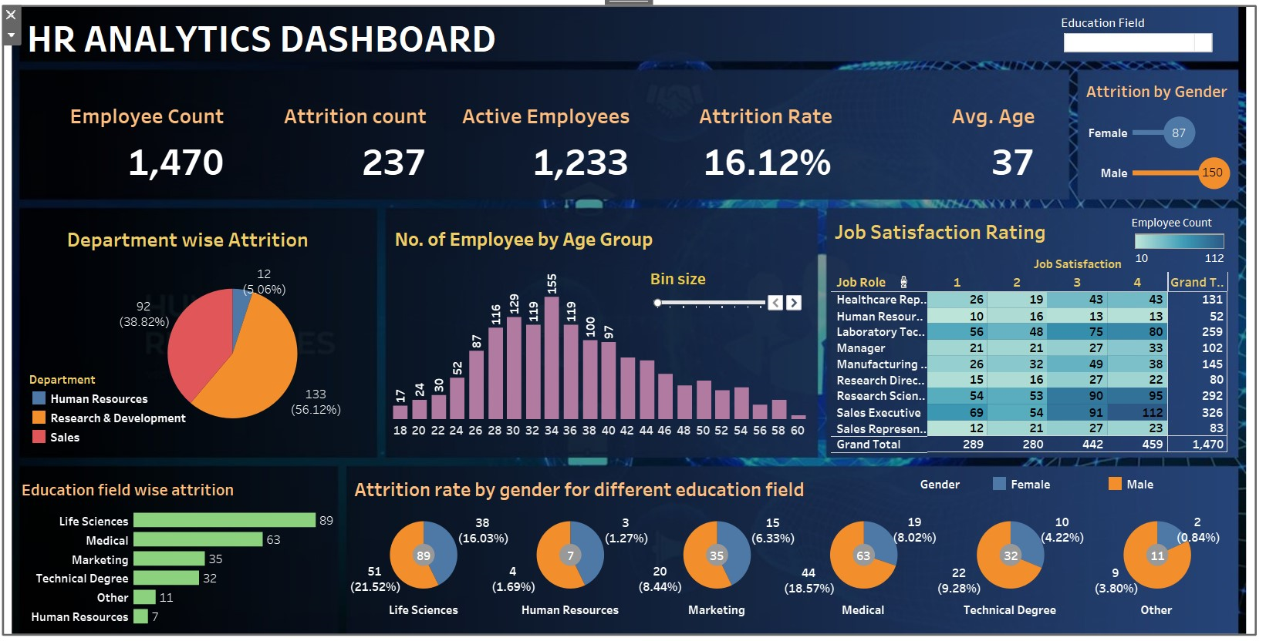

Link: https://drive.google.com/file/d/19EnKgN5GpoektNHqMdvUzXyaOhH_8hfP/view?usp=sharing

**Storyline:**

A data story is a way of presenting data and analysis in a narrative format, with the goal of making the information more engaging and easier to understand. A data story typically includes a clear introduction that sets the stage and explains the context for the data, a body that presents the data and analysis in a logical and systematic way, and a conclusion that summarizes the key findings and highlights their implications. Data stories can be told using a variety of mediums, such as reports, presentations, interactive visualizations, and videos.

**No Of Scenes of Story:**

The number of scenes in a storyboard for a data visualization analysis will depend on the complexity of the analysis and the specific insights that are trying to be conveyed. A storyboard is a visual representation of the data analysis process and it breaks down the analysis into a series of steps or scenes.

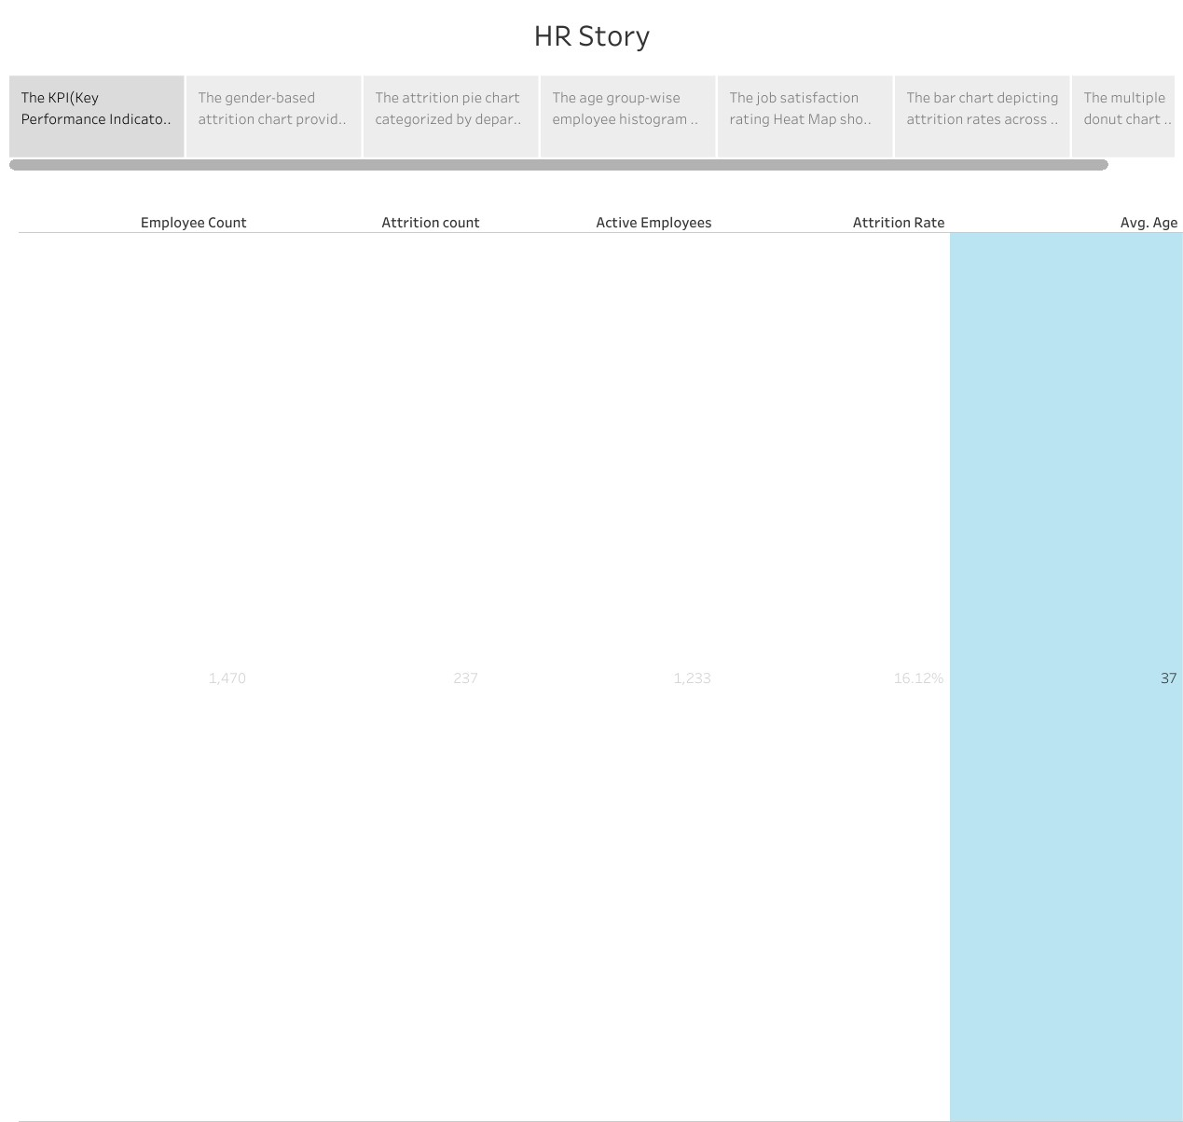

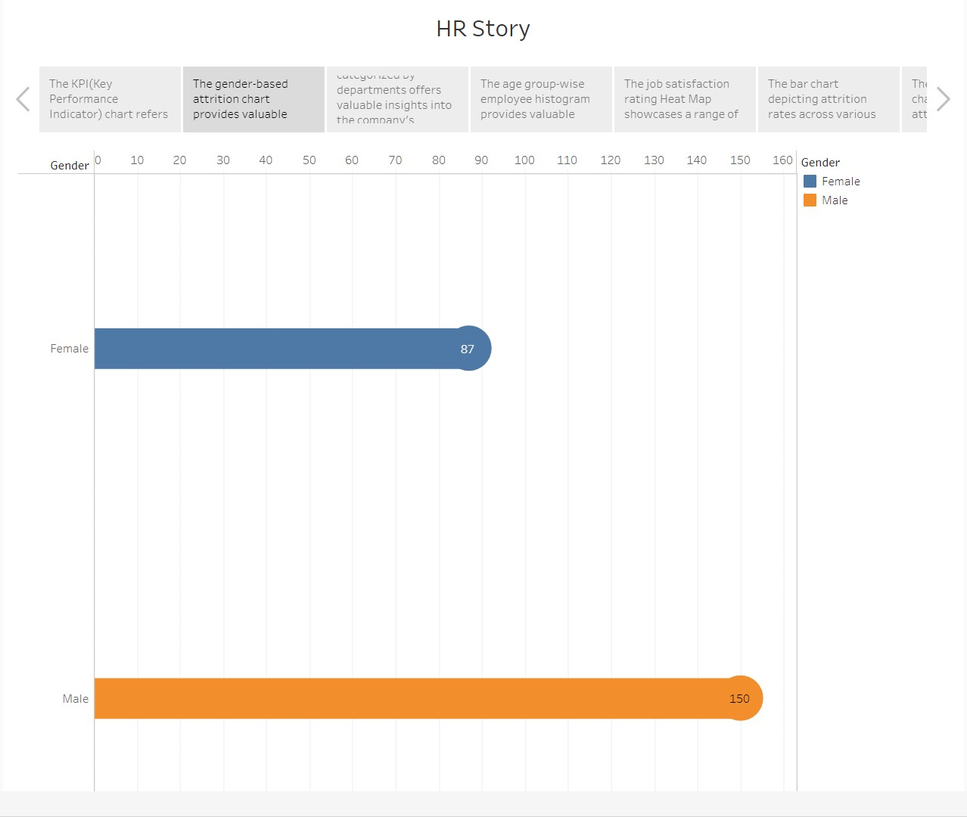

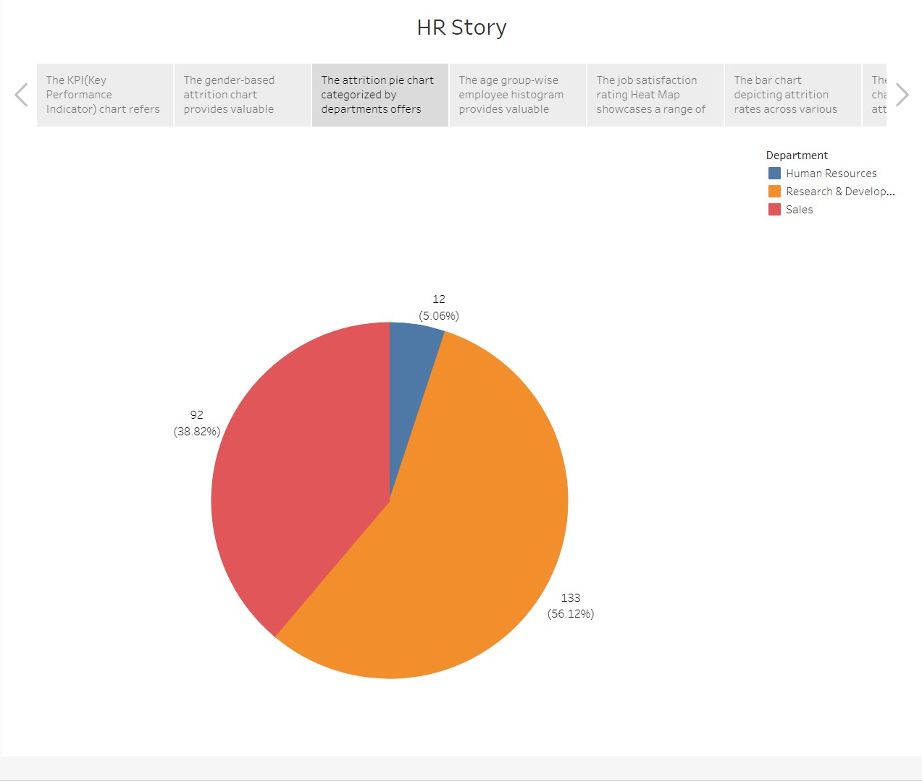

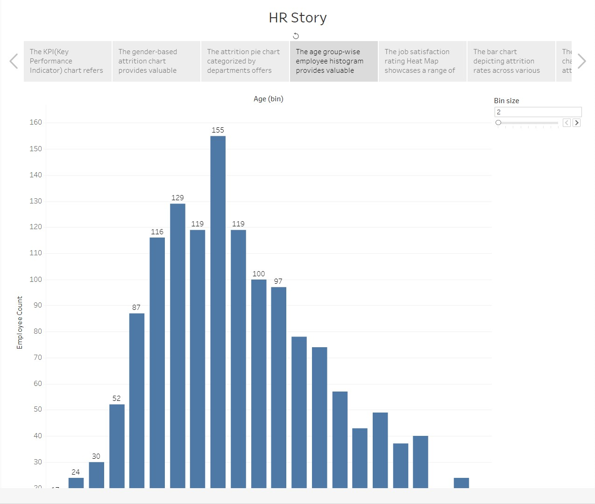

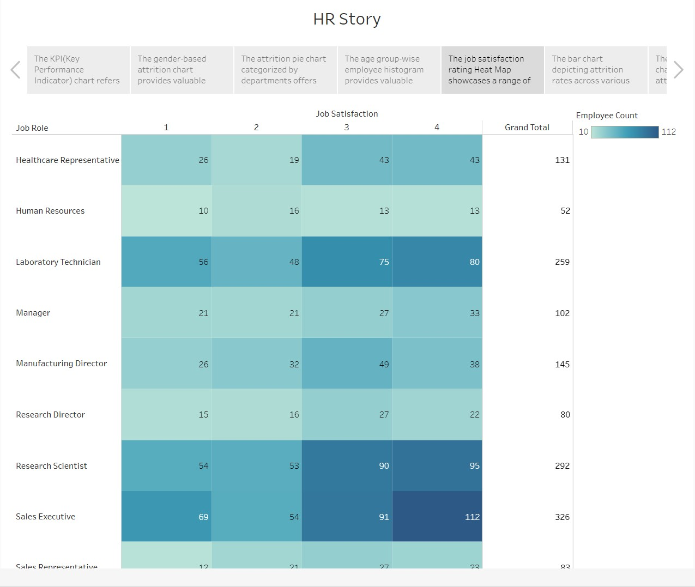

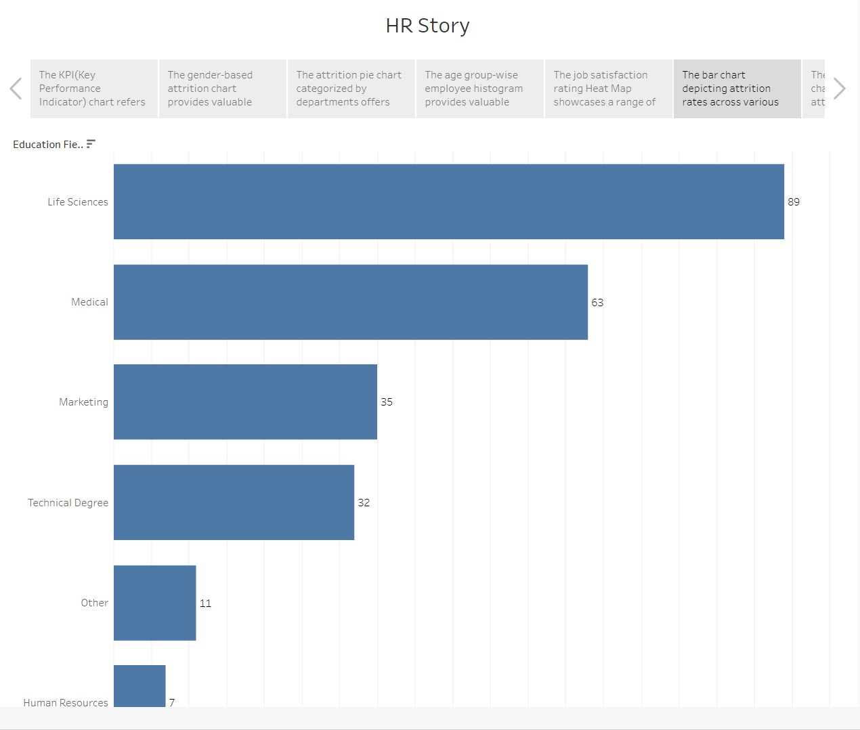

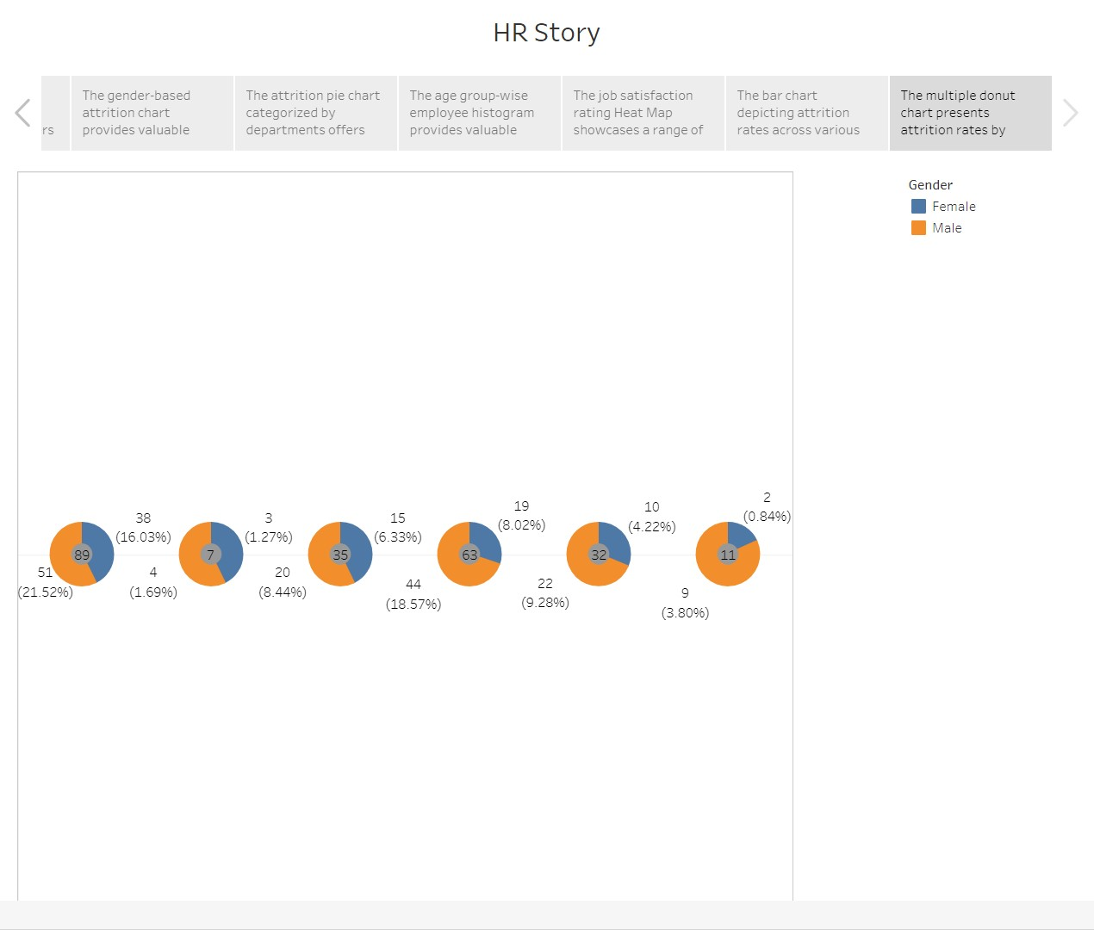

**Link:** https://drive.google.com/file/d/1HQEmX4jiHQxKozLcrdX0wSOTomE1c9iJ/view?usp=sharing

**Performance Testing:**

**Amount Of Data Rendered To DB**

The amount of data that is rendered to a database depends on the size of the dataset and the capacity of the database to store and retrieve data.

Open the MySQL Workbench, go to the database then click to expand the tables,select the table and click on (i) button to get the information related to the table such as column count, table rows etc.

**Utilization Of Data Filters**

Data filters play a crucial role in HR analysis in Tableau by allowing users to narrow down and focus on specific subsets of data. They help in exploring and analyzing data from various perspectives, uncovering patterns, and gaining insights

Below we have applied the filter for only Life Science Medical and Marketing and we see that the other visualisations are changing accordingly

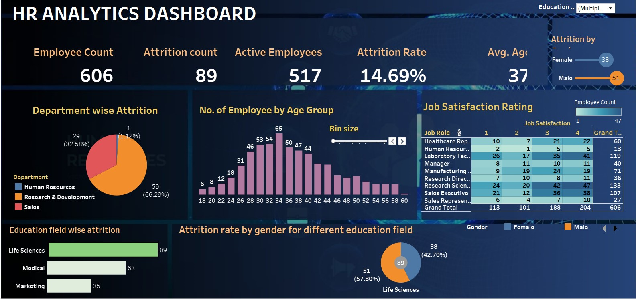

Similarly we can apply other filters and the changes in the dashboard will be seen accordingly.

**No Of Calculation Fields**

Calculation fields in Tableau allow users to create custom calculations using existing data in their datasets. These calculations can involve basic arithmetic operations, aggregations, logical conditions, string manipulations, and more. Calculation fields provide flexibility and enable users to derive new insights or perform complex calculations on their data

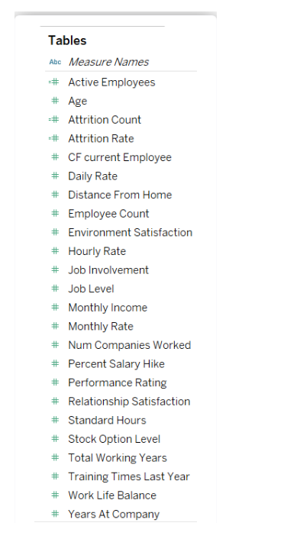

**Web Integration:**

Here is a summary of the steps we followed to integrate the modified Bootstrap template with the Tableau HR Scorecard dashboard and visualizations using Flask:

1) Selected a Bootstrap Template: We carefully chose a Bootstrap template that suited the design and layout requirements of the Tableau HR Scorecard project.

2) Modified the Template: We customized the selected Bootstrap template to align with the branding and visual style of our HR Scorecard project. We made changes to colors, typography, layout, and other elements to create a cohesive look and feel.

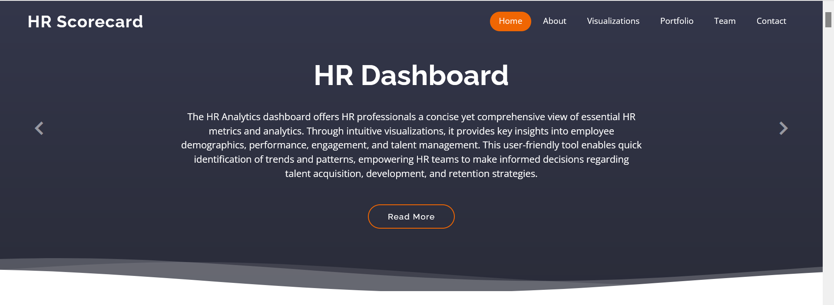

3) Built Flask Application Structure: We set up the basic file structure for our Flask application, including directories for static assets (CSS, JavaScript, images) and templates.

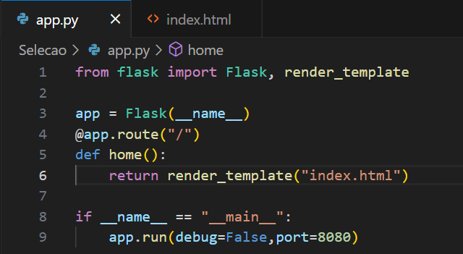

4) Defined Flask Routes and Views: We defined Flask routes and views to handle incoming HTTP requests and render the appropriate templates. We created separate routes for the dashboard, story, and individual visualizations.



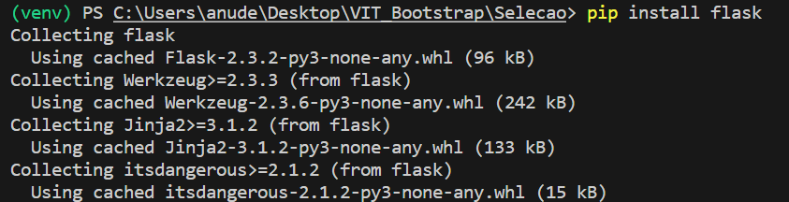

5) Managed Static Assets: We placed our modified Bootstrap template files, custom CSS, JavaScript, and other static assets in the appropriate directories within our Flask project's structure. We linked these assets to the HTML templates for proper styling and interactivity.

6)Embedded Tableau Visualizations: We followed Tableau's documentation to embed Tableau visualizations into our web application using HTML and JavaScript. We customized the embed code to fit within our Flask templates and ensure proper functionality.

7)Implemented Navigation and Interactivity: We enhanced the user experience by implementing navigation menus, buttons, and interactive features in our Flask application. We ensured smooth transitions between different sections of the HR Scorecard, such as switching between the dashboard, story, and visualizations.

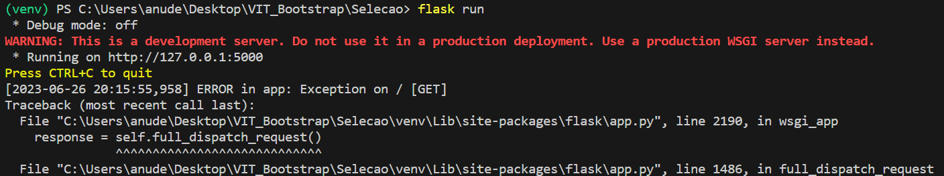

8)Tested and Debugged: We thoroughly tested our Flask application locally, identifying and addressing any errors or issues that arose during integration. We used Flask's development server and monitored the console for error messages and warnings.

9) Deployed the Application: Once satisfied with the functionality and design, we deployed our integrated web application to a production server or hosting platform. We followed deployment best practices for Flask applications, including configuring appropriate server settings and ensuring the security of sensitive information.

Overall, the integration of Tableau HR Scorecard dashboard and visualizations into our website, leveraging the capabilities of Bootstrap, transformed our HR analytics into an engaging and user-friendly web experience. The result is a visually compelling and data-rich platform that empowers organizations to measure success in talent management effectively.

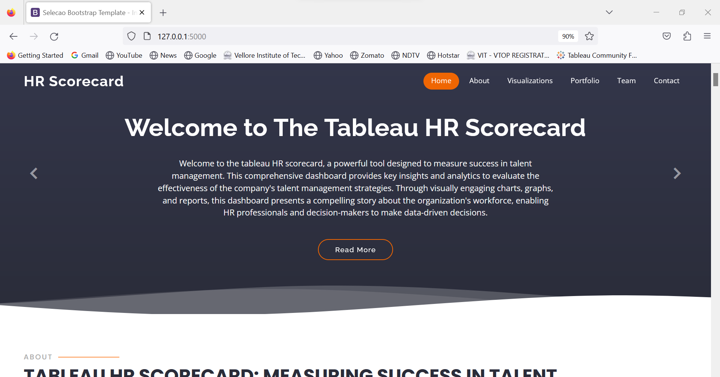

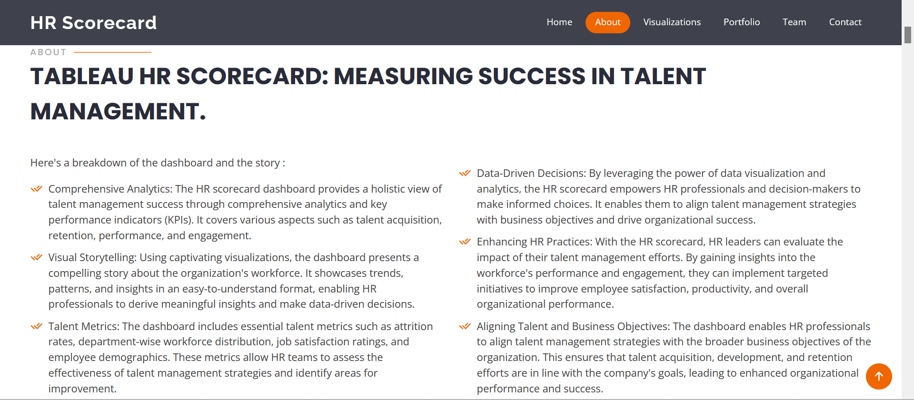

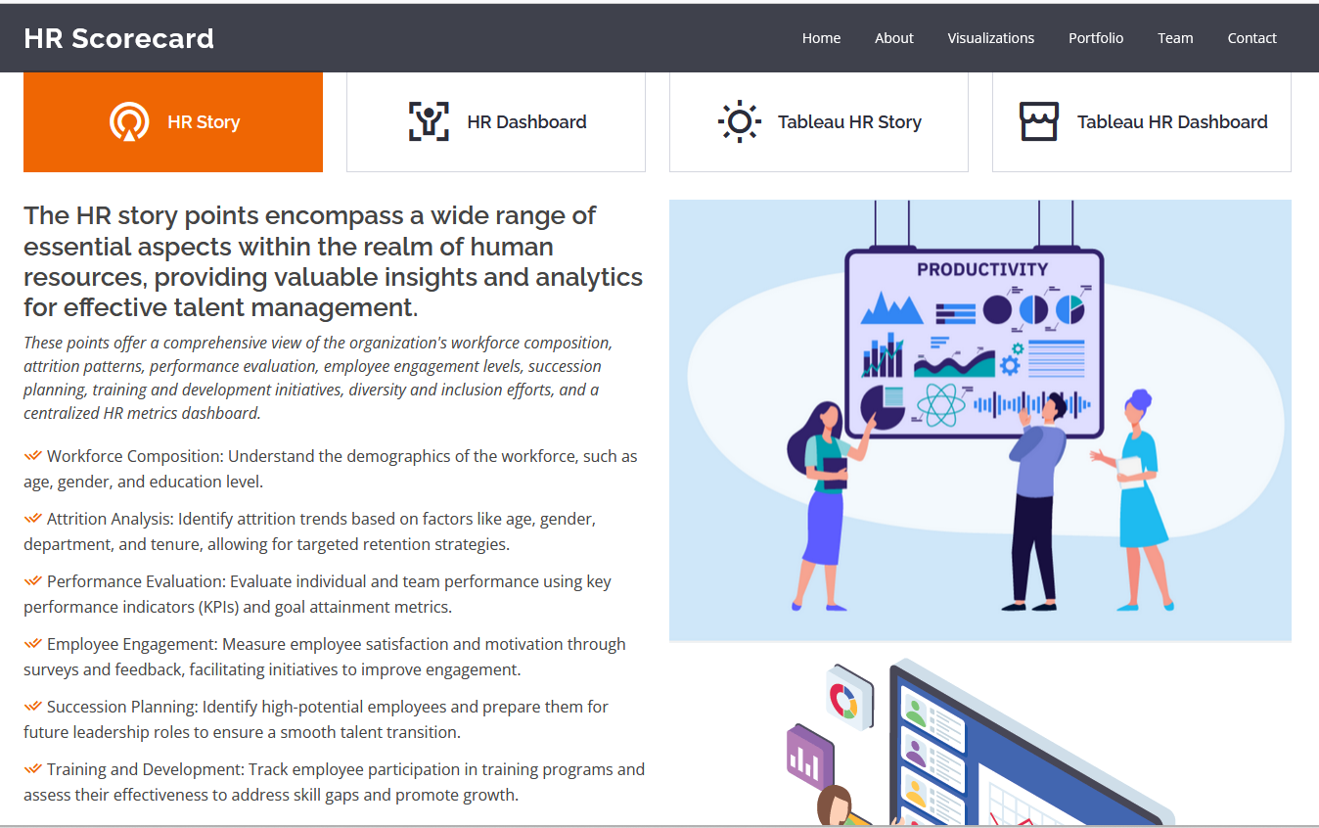

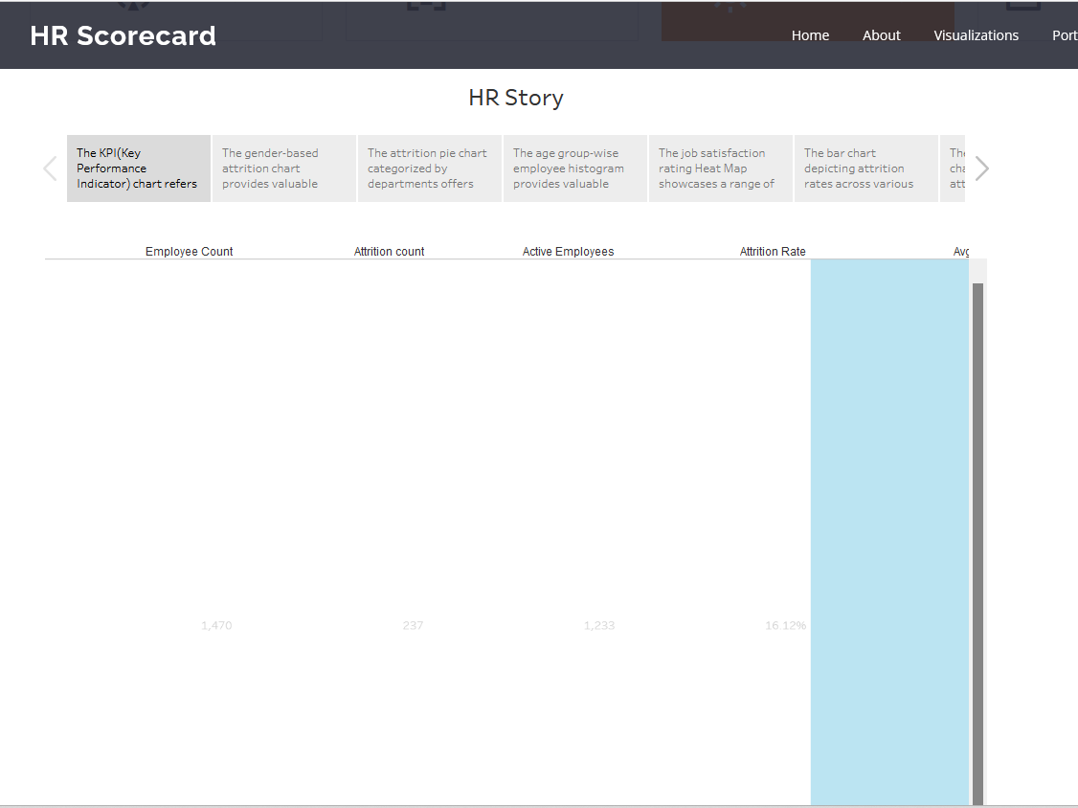

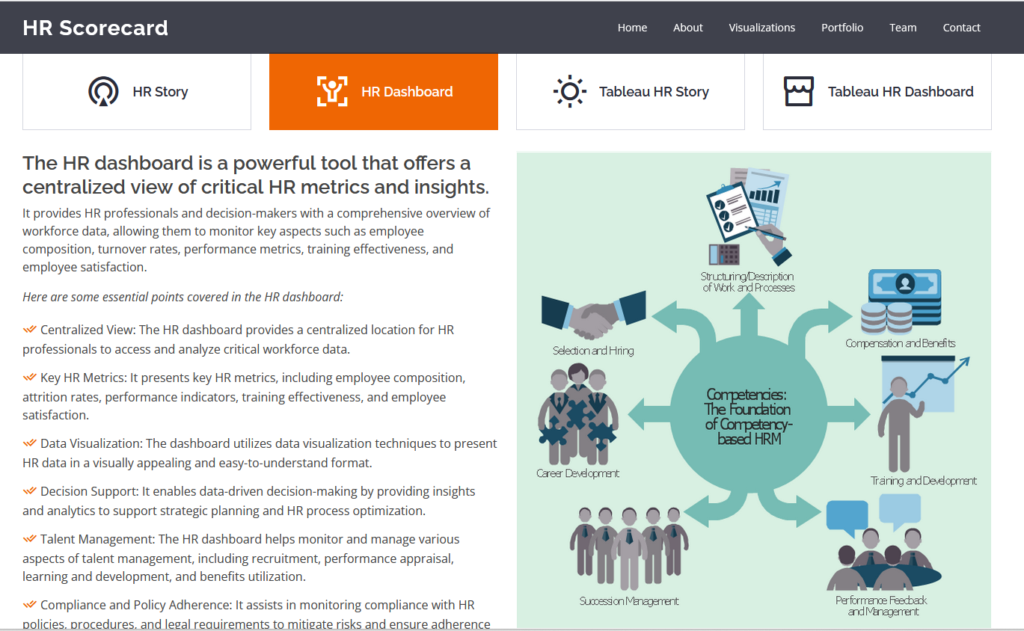

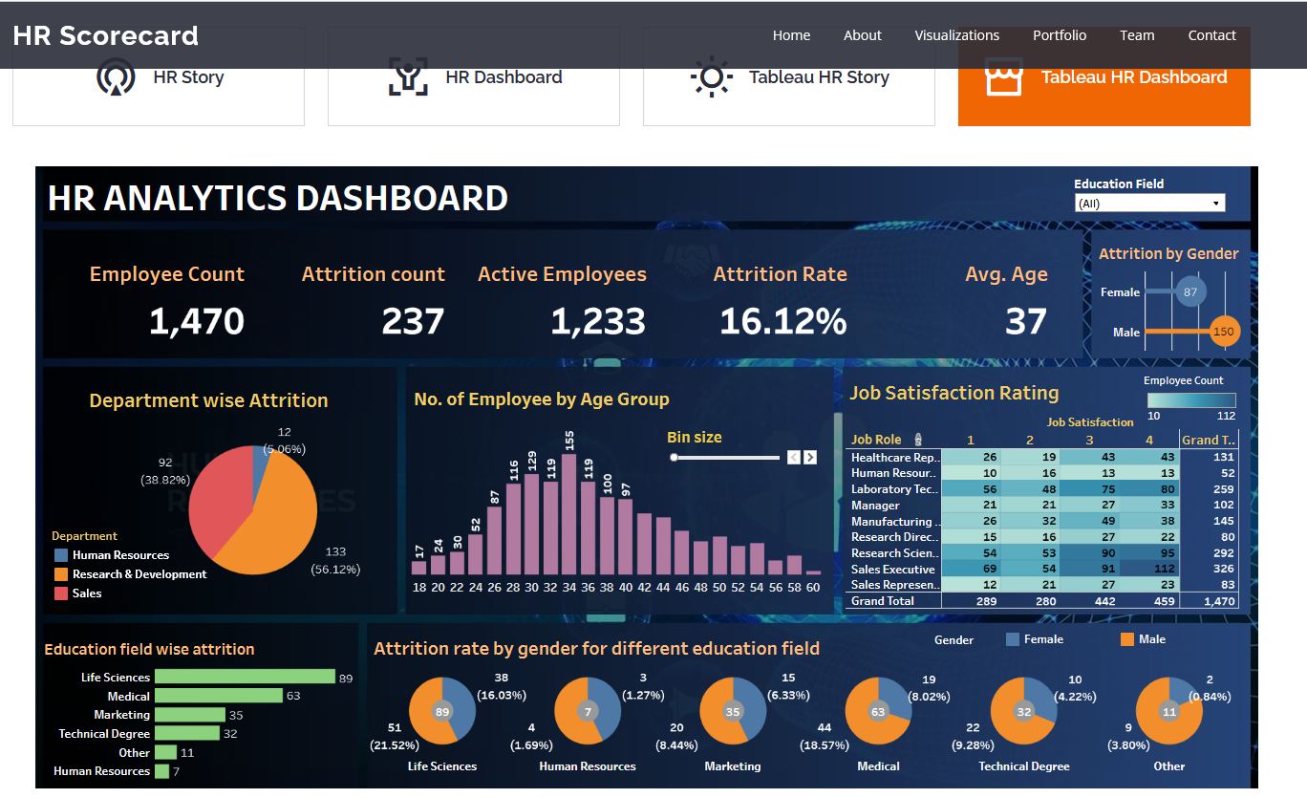

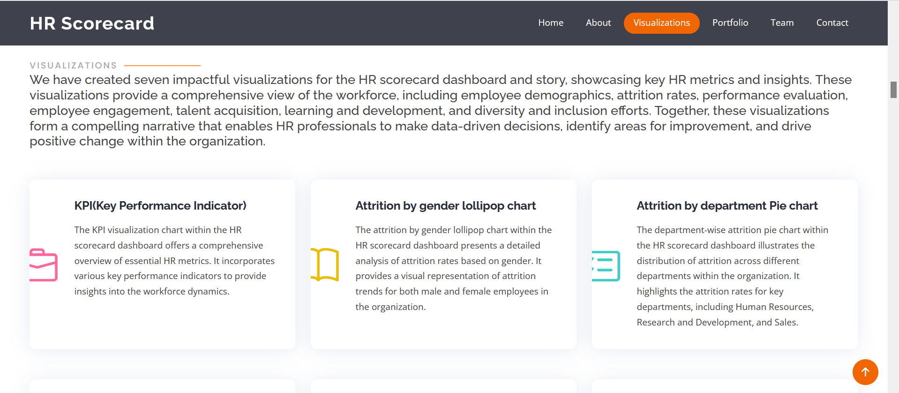

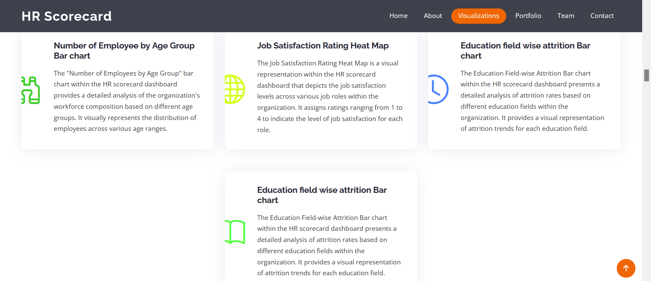

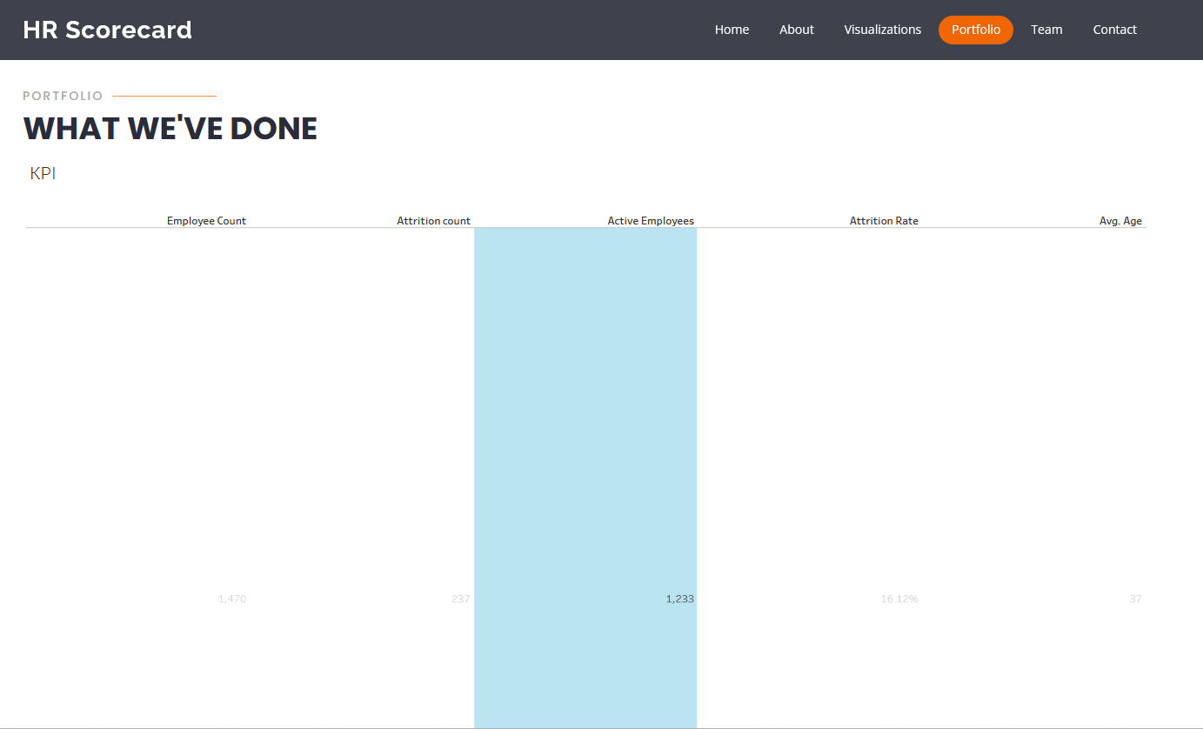

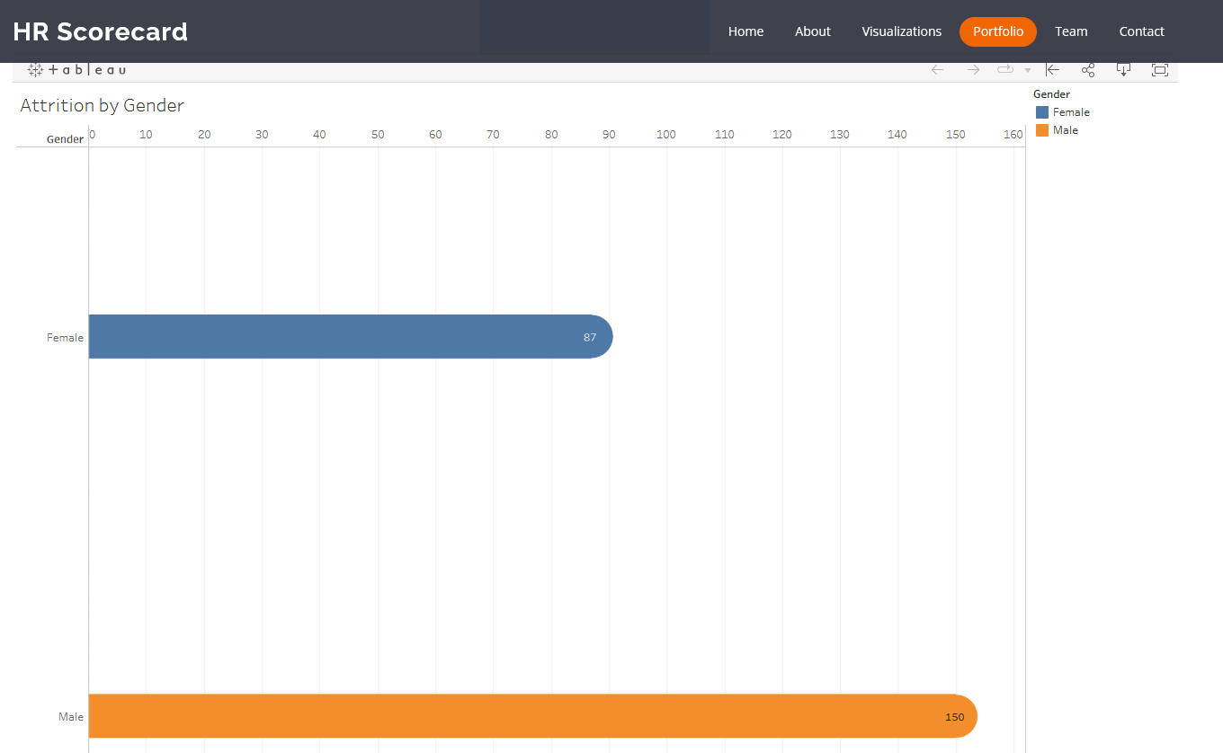

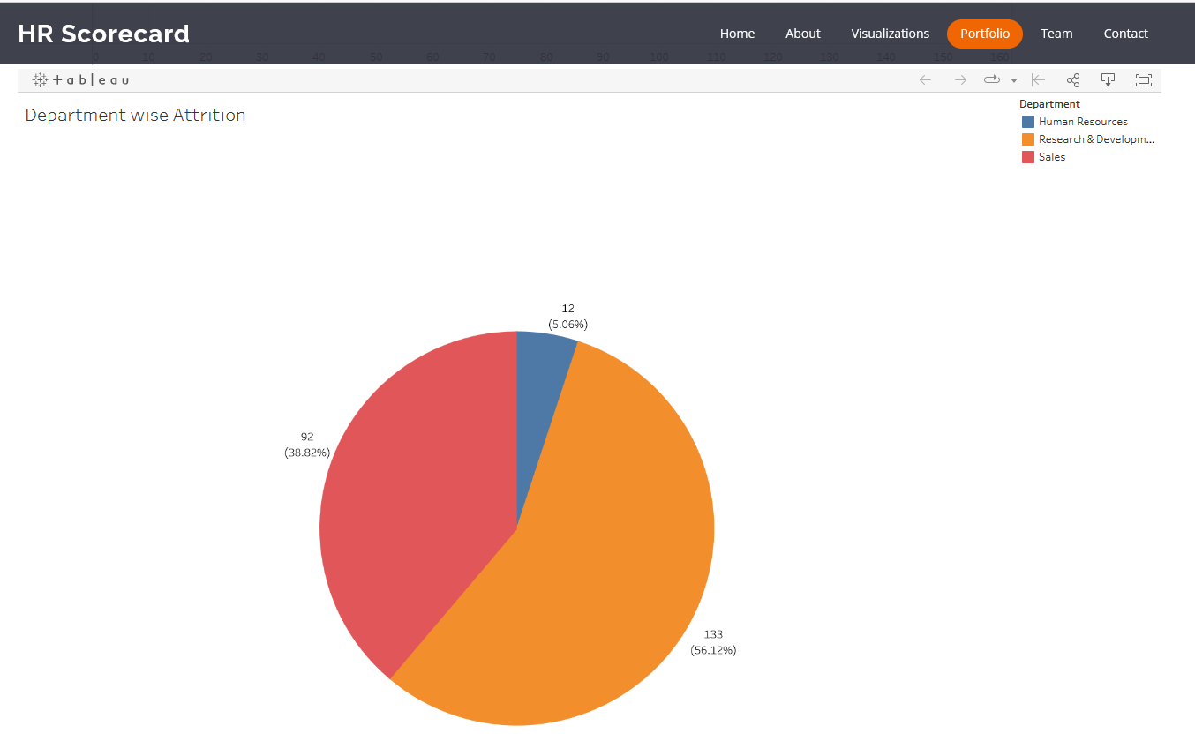

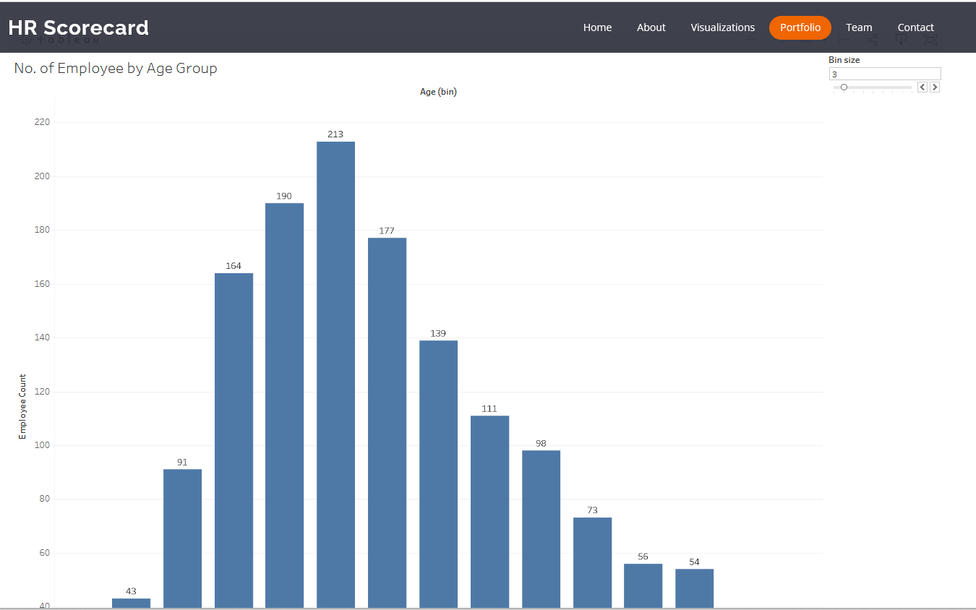

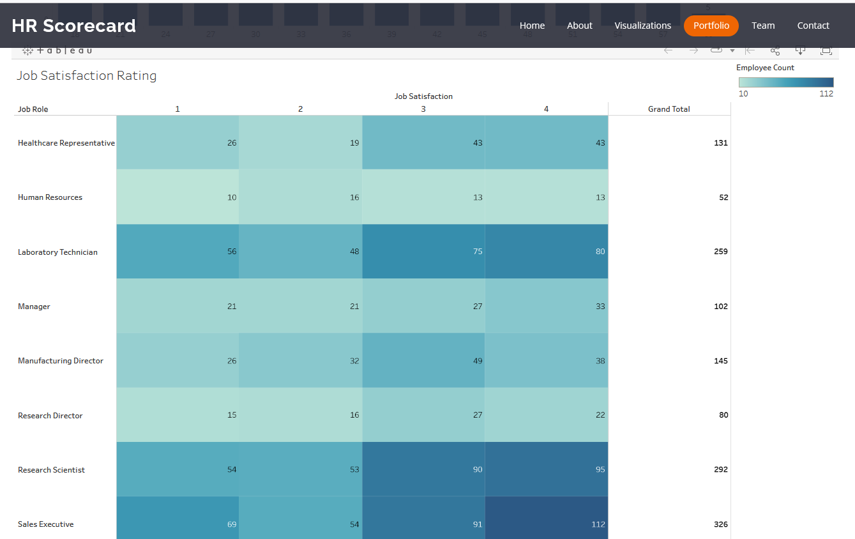

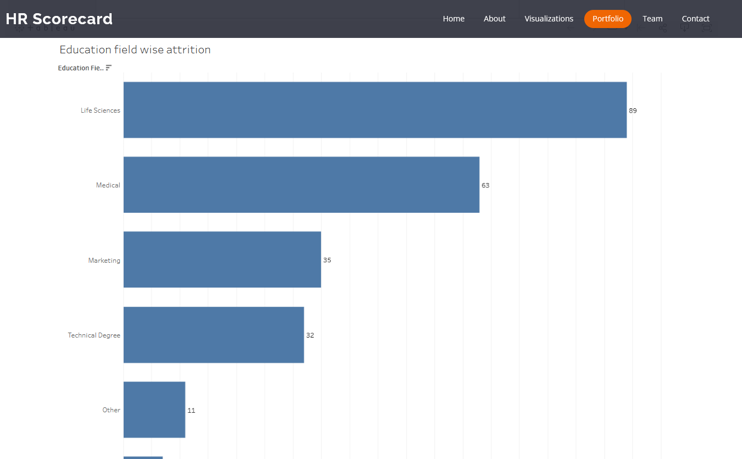

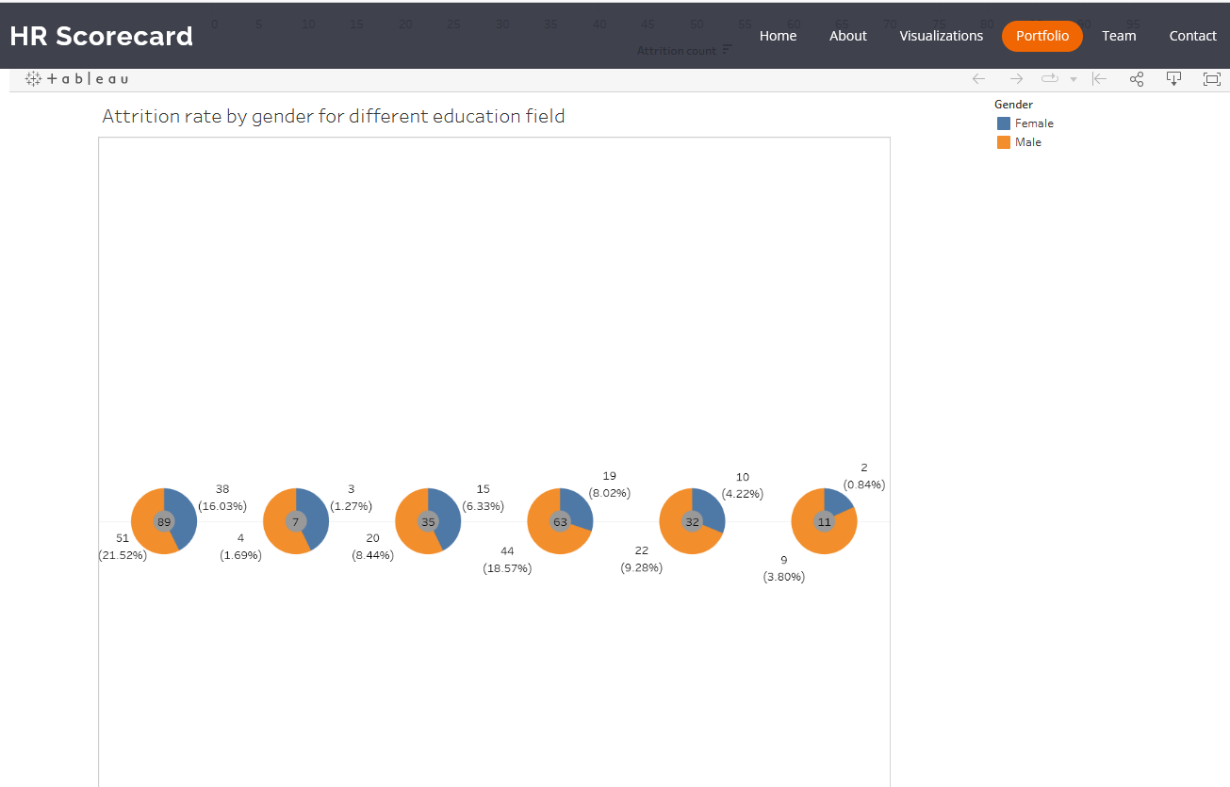

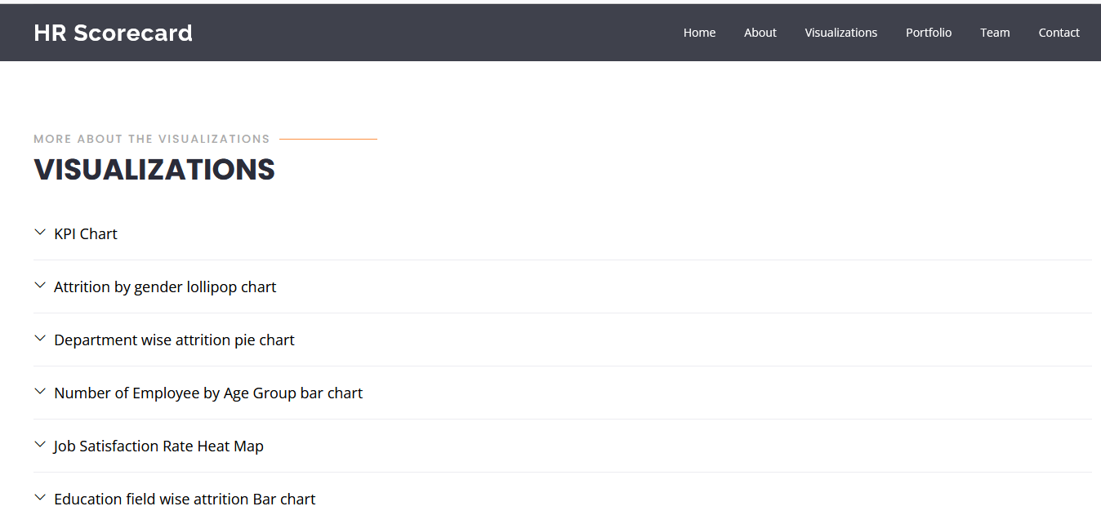

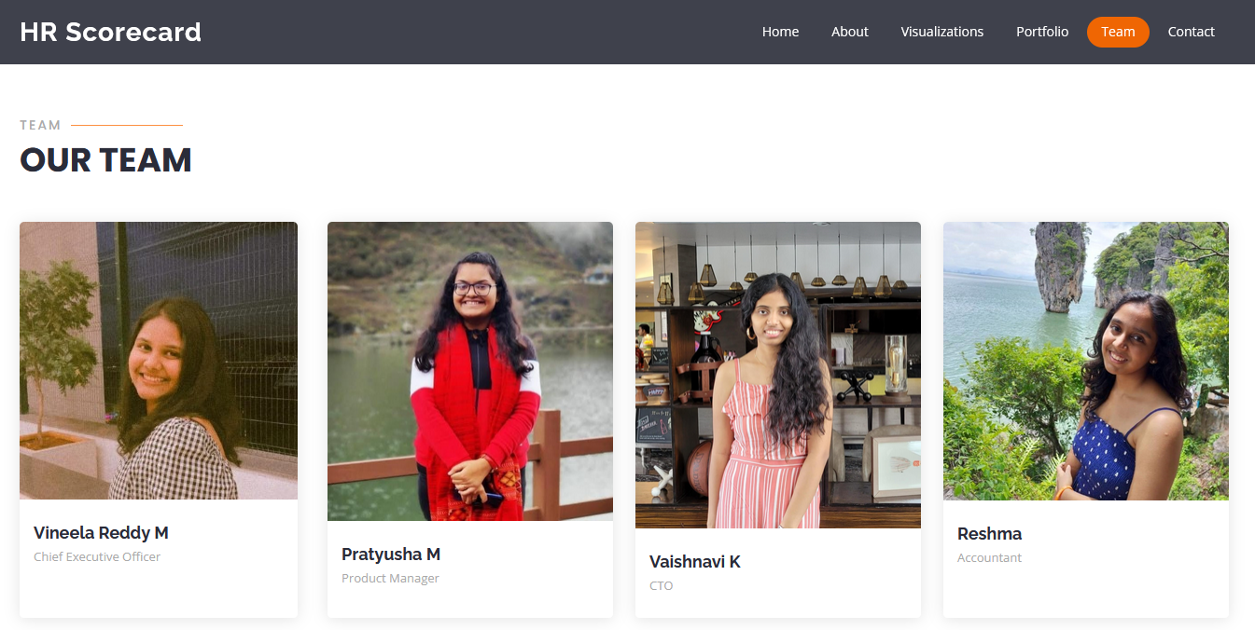

Link: <https://drive.google.com/file/d/1UKoh3OZDMY5VWAaVa9e7Tf8WXmVR8xXZ/view?usp=sharing>

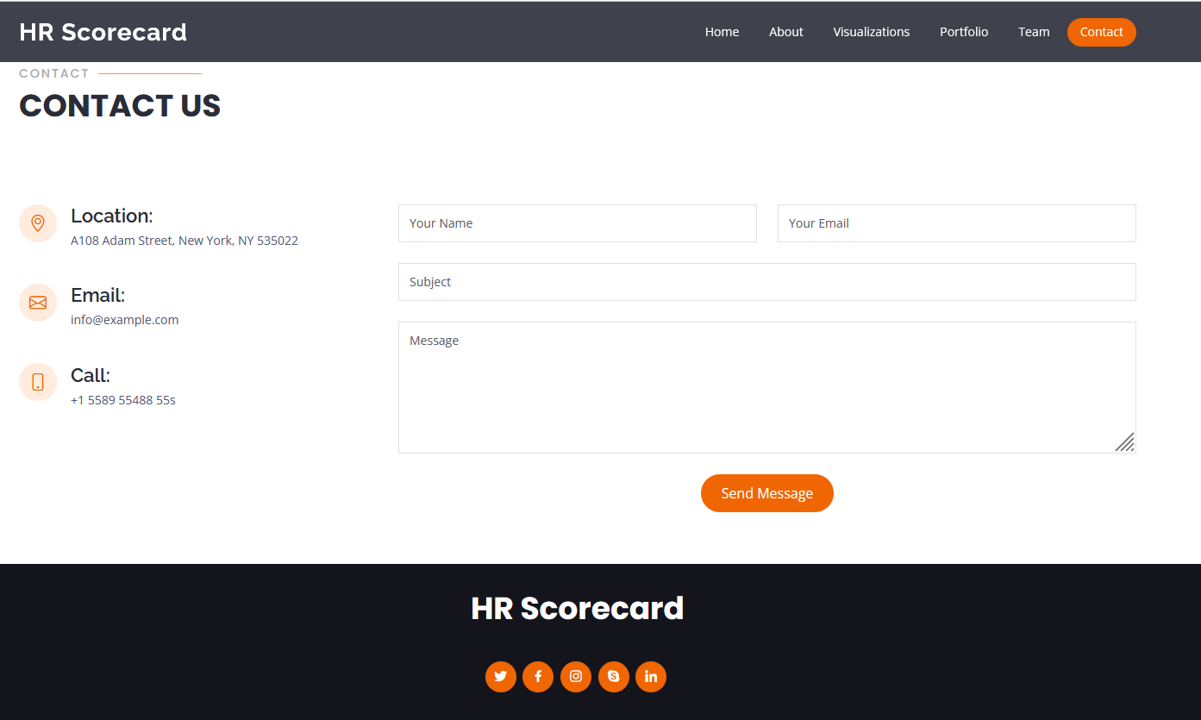

By following these steps, we successfully integrated the modified Bootstrap template with the Tableau HR Scorecard dashboard and visualizations, creating a web application that delivers an enhanced user experience and effectively measures success in talent management.

Link: https://drive.google.com/file/d/1UKoh3OZDMY5VWAaVa9e7Tf8WXmVR8xXZ/view?usp=sharing

**PROJECT DEMONSTRATION AND DOCUMENTATION:**

Complete explanation of working of the project:

<https://drive.google.com/file/d/1WFY0GMW8pDkxOn5v6okbTP0PUImVYym3/view?usp=sharing>

Complete explanation of the documentation:

<https://drive.google.com/file/d/1R-Rr2-Z0H2YI8NbCRyovymR3B-YFwNqp/view?usp=sharing>